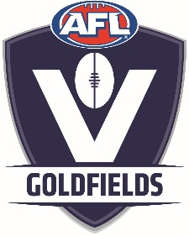
MEDIA RELEASE

COVID-19 UPDATE AND IMPACT ON 2020 SEASONS IN OUR REGION
17th March 2020

Following lengthy consultation with AFL Victoria and Government Health Experts, recommendations have been passed down for all Community Football Leagues, Auskick and School Programs in Victoria to postpone training and matches until 31st May.
AFL Goldfields accepts and endorses these recommendations.
For AFL Goldfields this incorporates all affiliated leagues/associations;
- McDonald’s Ballarat Football Netball League,
- Ontime Delivery Solutions Riddell District Football Netball League,
- McDonald’s Maryborough Castlemaine District Football League,
- Bendigo Bank & Rural Bank Central Highlands Football League
- AFL Goldfields Female Football League,
- Ballarat Football Umpires Association.
All League boards will determine how their season will look from here and fixtures will be created over the next few weeks to reflect the new dates.
We are working closely with AFL Victoria to work through this extremely unique situation.
This is a challenging time for everyone concerned. Knowing the positive impact that football & netball clubs have on our local communities, we will be working hard to ensure our seasons are ready to go when deemed safe.

End Release

For further details regarding this release, please contact AFL Goldfields Regional General Manager Gerard Ryan on 0408 563 980 or Gerard.Ryan@afl.com.au

